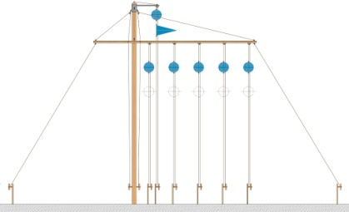
The Friends of the
Lines of
Torres Vedras
Visit to Stratfield Saye : Thurs 9th May 2019
By kind permission of his Grace the Duke of Wellington , President of the Friends, we are organising an exclusive visit to Stratfield Saye, the historic home of the Dukes of Wellington. The date also commemorates the 633rd anniversary of the Treaty of Windsor, signed with our longest ally, Portugal. https://en.wikipedia.org/wiki/Stratfield_Saye_House
Numbers are strictly limited, so early booking is advised!
We are offering two package options:
option 1: breakfast at the Cavalry and Guards Club, Piccadilly with return coach travel to Stratfield Saye
Breakfast 8 am, coach departure 9.00 am
Breakfast menu includes: bacon or sausage rolls; (V) fried egg; haddock kedgeree; tea or coffee; orange Jjuice.
together with morning coffee, light lunch and afternoon tea at Stratfield Saye, as set out under option 2
Cost: £65 for members and £80 for non members.
Option 2: your own transport to Stratfield Saye (arrive for 10.30am)
including morning coffee and biscuits; light lunch (quiche, meat pasty, or ploughmans, all with salad, tea/coffee, water); and afternoon tea and cake (take your own alcohol as the House is not licensed).
Cost: £35 to members and £50 to non members.
finally, breakfast only: if you wish only to come for the Treaty of Windsor commemorative breakfast, this is available at £15
To reserve and pay for your place, or enquire about FOLTV membership (£20 pa) please email our treasurer Mary Brewer: hib0u@msn.com
Best wishes
Andrew Dismore Chairman FOLTV and Ian Brewer visit coordinator

