Friends’ Visit to Winchester Military Museums

Saturday 29th April 2023

As readers will know, our towns and cities are now divided into quarters (though there are usually more than four) and Winchester is no exception. Thanks are due to Marcus Cribb and the Committee for organising today's visit to the Winchester Military Quarter. This is based around the former Peninsula Barracks, formerly the depot of the Rifle Brigade in its various incarnations. Nowadays the barrack blocks have been converted to (I suspect very expensive) flats and the parade square laid to box hedges, lawns and a fountain. The porticoed Guardroom has become a café though the entrance is still presided over by a statue of Sir John Colborne, CO of the 52nd in the Peninsular and at Waterloo.

About a dozen Friends gathered in front of what certain Committee members had referred to as the Rifles Museum at 10.30 on a lovely, sunny Saturday morning. Most of us had dined the previous evening at the Winchester Royal hotel where it was good to catch up since the Portugal trip last October. The organisers had issued no warning about the length and steepness of the walk from hotel to Barracks - very Black Bob Craufurd - but it may have served to dispel any hangovers.

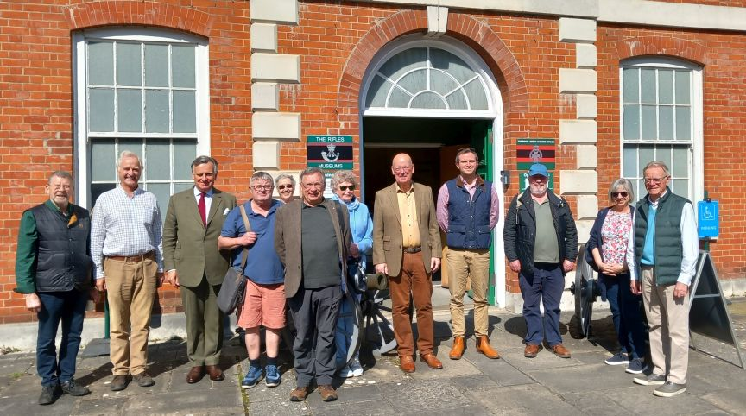
Mary Brewer Elaine Roberts Marcus Cribb (tan boots)
Mike Hyde Mark Crathorne Bernard Hornung Ian Brewer Andrew Dismore Chris Roberts Will Bennett
Kathy and Mike Martin

It might be worth explaining to the Committee , whose knowledge of the Regimental system to some might not be all that it could be, that this Museum deals with the Royal Greenjackets (RGJ) and not the Rifles. The RGJ was created in 1958 and its three regular battalions brought together the former 43rd / 52nd (Ox & Bucks), the King’s Royal Rifle Corps (KRRC, formerly the 60th) and the Rifle Brigade (formerly 95th). In 2007 the RGJ were merged into something called the Rifles which also absorbed all those Regiments with a Light Infantry designation.

There had been a serious fire at the Barracks in 1894 and so the current buildings date from the Edwardian era. Their style is considerably more opulent and grander than the mock-Gothic castles that sprang up around the country after the Cardwell reforms of 1881.

As indicated earlier, these Barracks were the depot both of the Kings Royal Rifle Corps (KRRC) and the Rifle Brigade from 1858 to the mid 1980's and it is a bit difficult to imagine the crowds of soldiers, vehicles and stores that must have filled the place over the decades.

Apart from the Museum of the RGJ one can buy a joint ticket (£11) to Horsepower (the Museum of the 10th and 11th Hussars) and the Museum of the Gurkhas which is what the Treasurer did.

The Museum of the Rifles (actually RGJ) https://rgjmuseum.co.uk/visiting/find-us/

Most Friends will have been primarily interested in the sections on the Peninsular War and Waterloo. Any story of light troops in the British Army will start with the American War of Independence and the creation of the Royal American Regiment (numbered 60th and known as such until 1958 when it was amalgamated with the RGJ). What is generally not shown is that the line towards the 43rd / 52nd and the 95th in the Napoleonic Wars was not a straight one. There was serious disagreement in the Army in the 1780's and early 1790's as to how relevant the tactics of the American War were to what we would now call conflict with a peer enemy in Europe. In America the troops tended to fight in open order because of the tangled terrain and the general absence of a cavalry threat. This would certainly not be the case in Europe and by 1793 the Army was definitely trained to fight in close order though in two ranks rather the 18th century three.

So the creation of the Light Infantry and 95th at Shorncliffe did not spring directly from the American War but as a result of the extensive use of skirmishers by the French in the Revolutionary Wars. The training of the Light Infantry at Shorncliffe in 1803-05 owed much to the recruitment of soldiers recruited from Germany and Switzerland during the Duke of York's campaigns in Flanders 1793-95 though the names of foreigners like Hompesch and de Rottenberg have tended, in the usual British fashion, to be overlooked in favour of our own Sir John Moore and Kenneth Mackenzie. But the training and expertise of the 5th Battalion 60th Regiment formed in 1797 fed directly into the Experimental Corps of Riflemen around 1800 and then into the Shorncliffe exercises directed by Moore.

This is not just me. Here is the Museum caption on the subject:

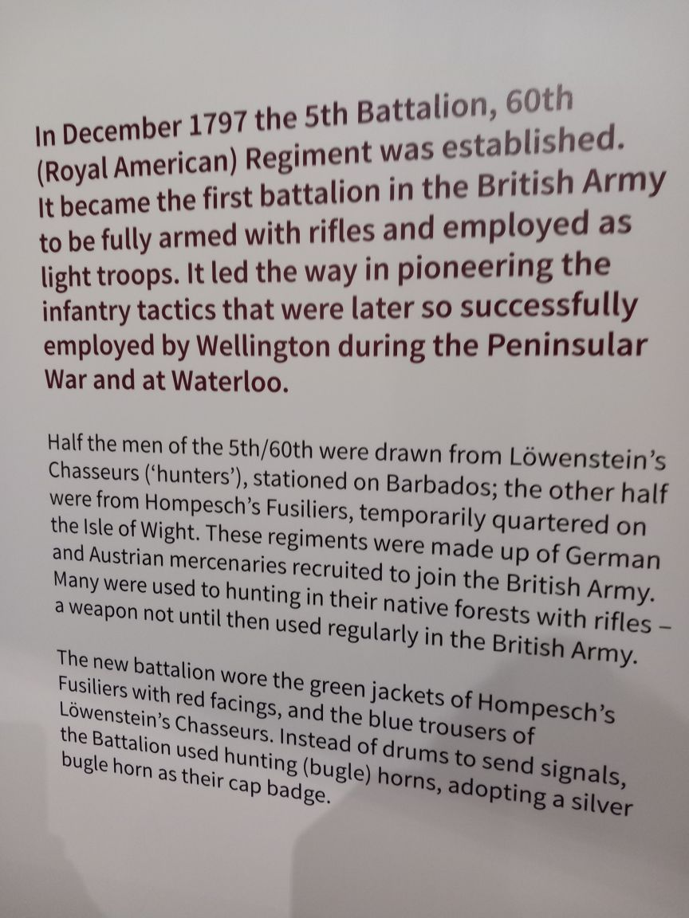

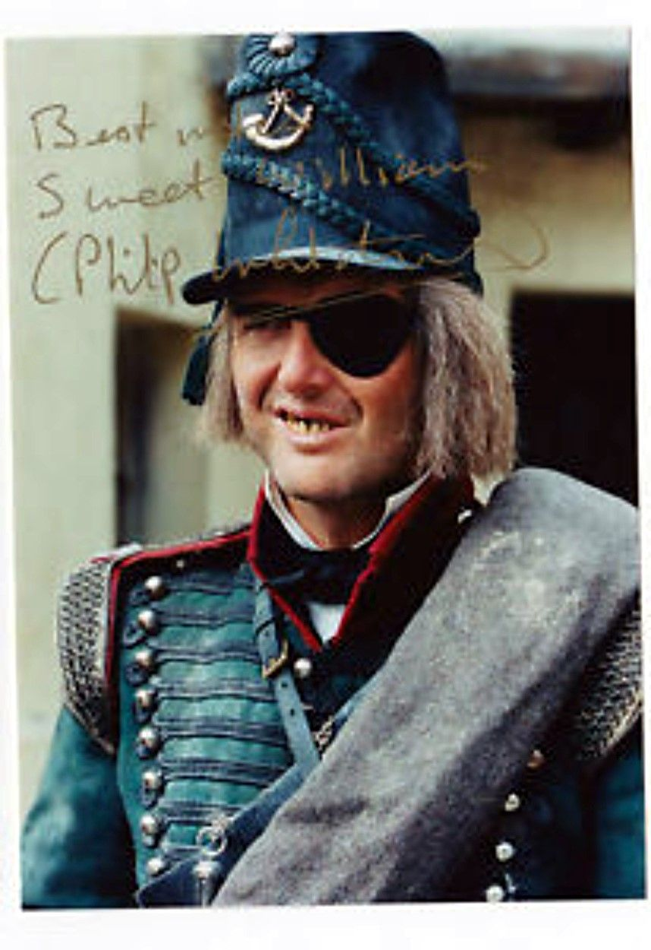 | In the Sharpe TV series, the influence of the foreigners is reflected in the colourful Captain Frederickson, the Anglo-German officer with his wig and wooden false teeth who I always felt was a much more interesting and sympathetic character than the Yorkshire chip-on-the-shoulder Sean Bean. People like the fictional Frederickson were formed into the 5th Battalion 60th Regiment in 1797 which was the first unit in the Army to be equipped solely with rifles.

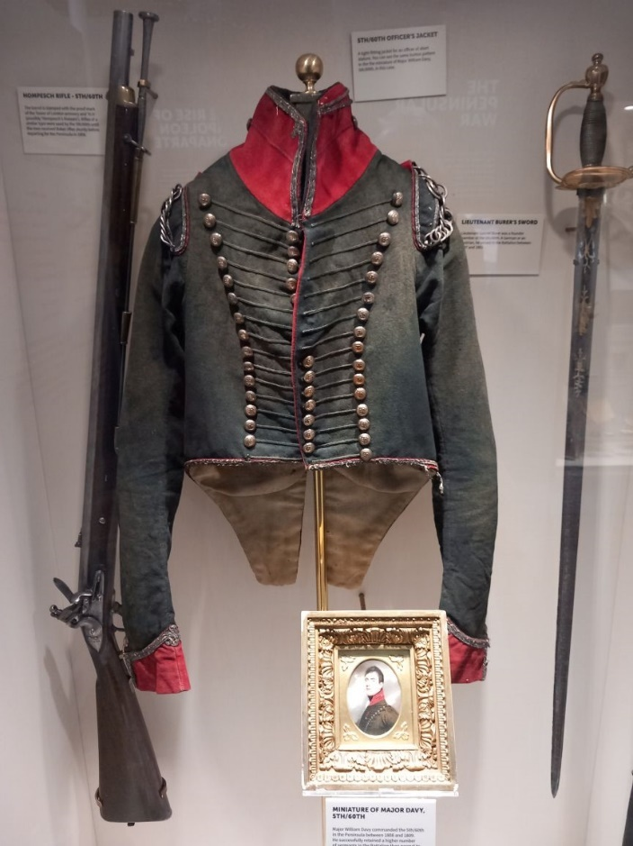 | 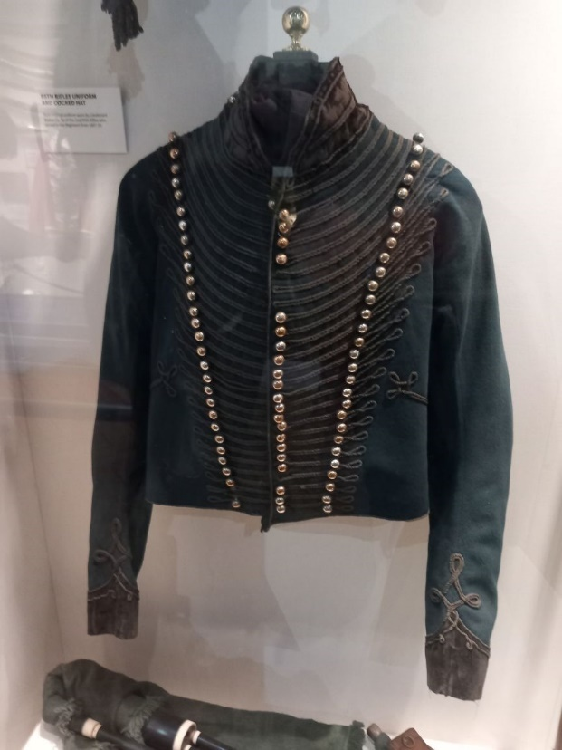
Coatee and gear of Maj Davy, 5/60th | Officer’s coatee 95th

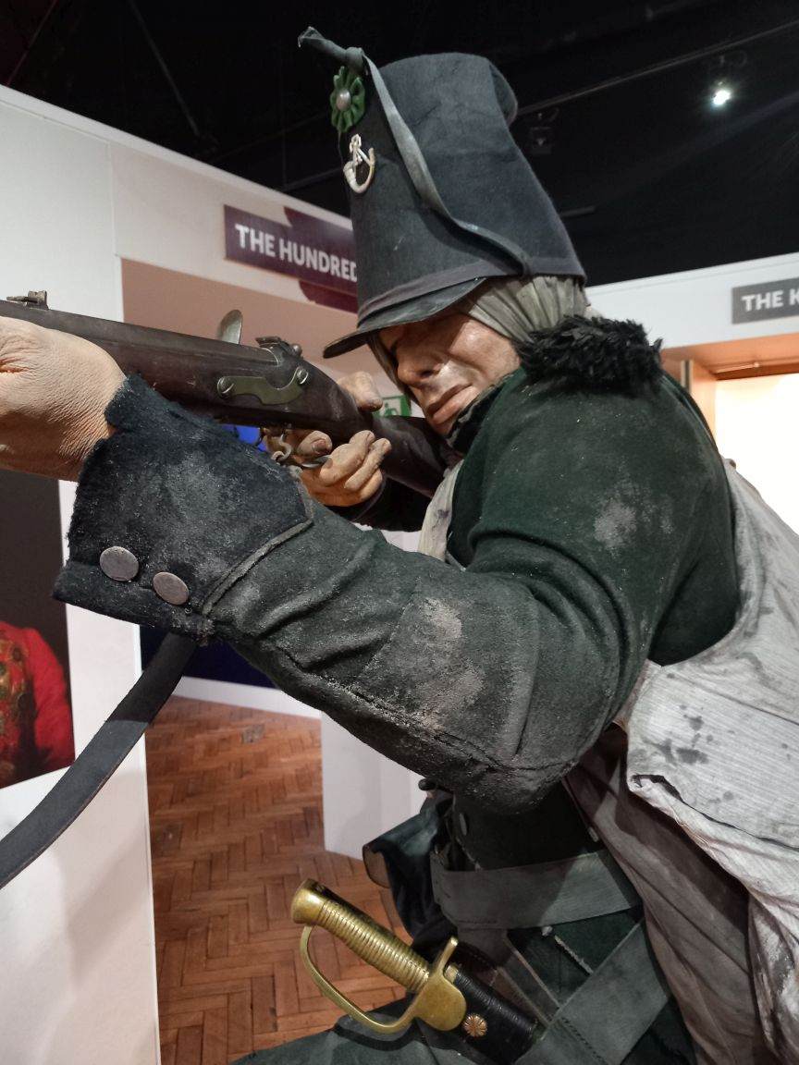 | The Peninsular War display is dominated by a life-size figure of Rifleman Harris resting his Baker Rifle on the branch of a tree to shoot. His patched uniform and feet bound with cloth remind us of the privations attached to warfare in the pre-industrial era. You have to walk everywhere, are issued one uniform per year and even when you have found some food it is very difficult to find the time and wherewithal to cook it. No wonder soldiers were undernourished and prone to straggling on forced marches.

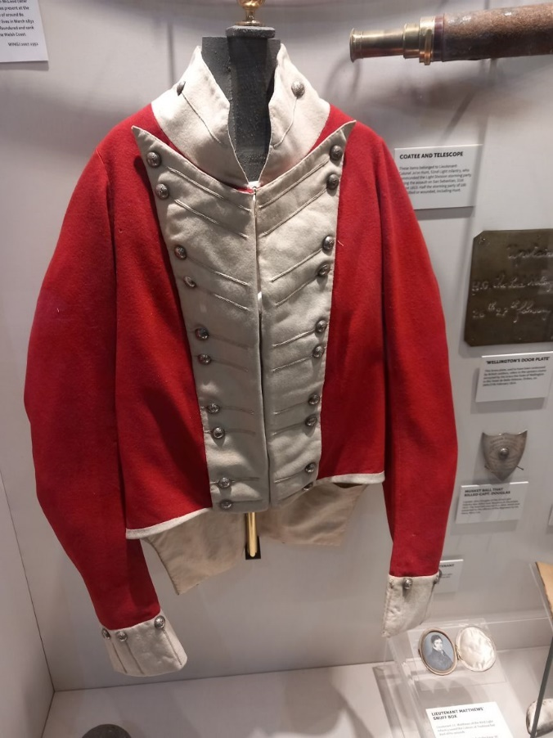 | 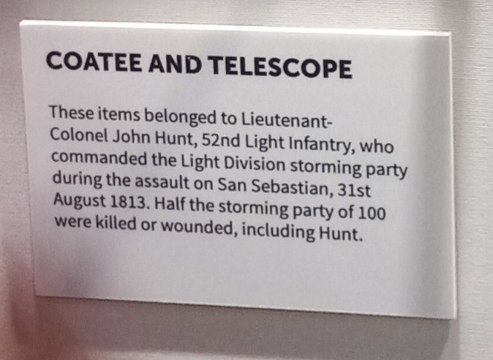  The third element in the Light Division was the red-coated light infantry of the 43rd and 52nd Foot.

The main exhibit on Waterloo is the diorama narrated by Kate Adie but this is such a familiar story that I found I was drawn towards some of the other artefacts.

The displays in the post-Napoleonic era included well-known campaigns like the Crimea and the Indian Mutiny but also many others of which I had never heard. Will Bennett had an advantage here as he had discovered that whilst the records might suggest that a particular Regiment had sat in Barracks in India for forty years, in practice many specialists such as signallers or transport men might be detached for service with expeditionary forces.

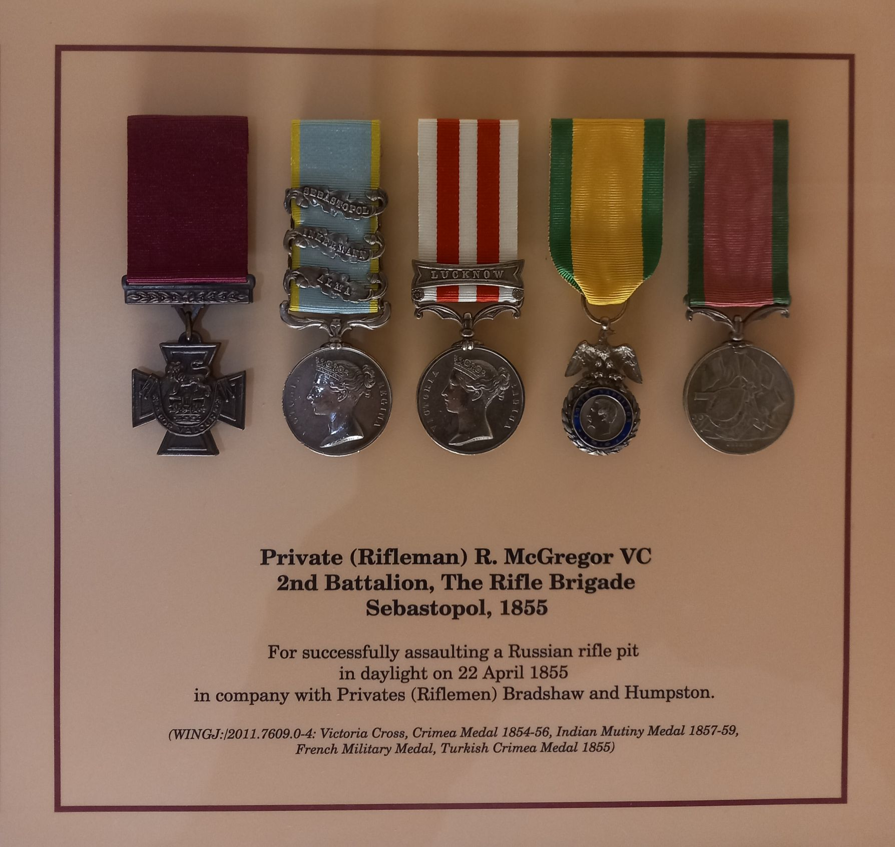

I was intrigued to find that in WW2 seventeen Americans were commissioned into the KRRC (formerly Royal Americans) of whom four were killed and several others wounded.

Books on the Light Infantry and Rifles
Gates British Light Infantry Arm https://www.amazon.co.uk/British-Light-Infantry-Arm-1790-1815/dp/0713455993

Rob Griffith History of the 5/60th https://www.helion.co.uk/military-history-books/riflemen-the-history-of-the-5th-battalion-60th-royal-american-regiment-1797-1818.php?sid=7a3a0de23e4d68abac59753643f1b57d Rob gave a very good talk on this book at a Conference at Bingham, Notts just before Covid.

Horsepower
This is the Museum of the 10th and 11th Hussars, the latter Regiment perhaps being the more famous as of Lord Cardigan and Light Brigade fame. They seemed to have acquired their nickname ‘The Cherrypickers’ during the Peninsular War when a patrol was captured in a cherry orchard though their reputation seems to have recovered after the Battle of El Bodon in 1811 https://www.britishbattles.com/peninsular-war/battle-of-el-bodon/ . More recently they acquired a fine reputation as an armoured car Regiment right through the desert war in WW2 and then in North-West Europe. This Museum is much smaller than the Rifles but whilst the curators have done a good job in a very confined space there is not a great deal on the Peninsular War or Waterloo. This may be because they do not have many artefacts from the period.

Both Regiments served in the Peninsular and in the Waterloo campaign but only the 10th were uniformed as Hussars. The 11th were dressed as Light Dragoons.

One of the most famous Hussar actions was at Benavente on 29th December 1808 during the Retreat to Corunna in which the 10th, 15th , 18th and 3rd KGL Hussars ambushed a French force with included the Chasseurs à Cheval of the Imperial Guard and captured General Charles Lefebvre-Desnouettes, the French cavalry commander. This website has a fair amount of detail. https://www.britishbattles.com/peninsular-war/battle-of-benevente/ . It is fair to say that several soldiers, from different Regiments received awards for the capture!

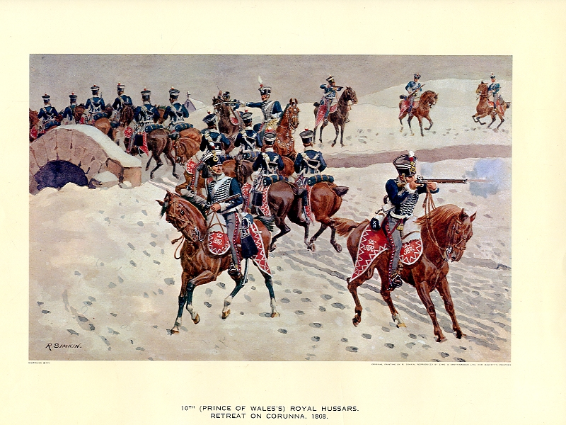 | An image by Richard Simkin (1850-1926) of picquets of the 10th Hussars during the Retreat from Corunna. Though wearing campaign dress, did they really use those crimson shabraques on campaign? Also, did not Hussars wear busbies rather than shakoes?

Although not relating the Peninsular War, I was surprised to find that Norman Wisdom served in the 10th Hussars from 1932-1935 and became the Army Flyweight boxing champion in India.

I found more information on these Regiments at these links

https://www.britishempire.co.uk/forces/10thhussars.htm

https://www.britishempire.co.uk/forces/armyunits/britishcavalry/11thltdragoons.htm

Gurkha Museum
We made our own arrangements for lunch and in the afternoon most of us visited some of the other Museums, particularly that of the Gurkhas. This is again very well laid out and has clearly benefitted from donations by former members, mainly officers. I found it slightly incongruous to be reading about the qualities of peasant soldiers in one of the most remote areas of the world whilst located in the city with the least deprivation anywhere in England or Wales. I suppose it heightened my awareness that we were in a different world. The displays commenced with a map of the various tribe and clan areas in Nepal together with photos, film clips and artefacts. Most people know that the Gurkhas became linked with the British Army when we got fed up with their raids during the period of the Napoleonic Wars and so launched a campaign from 1814 to 1816 to deal with them. For Lord Ochterlony and the other red-coated officers one felt that the Peninsular must have been another planet.

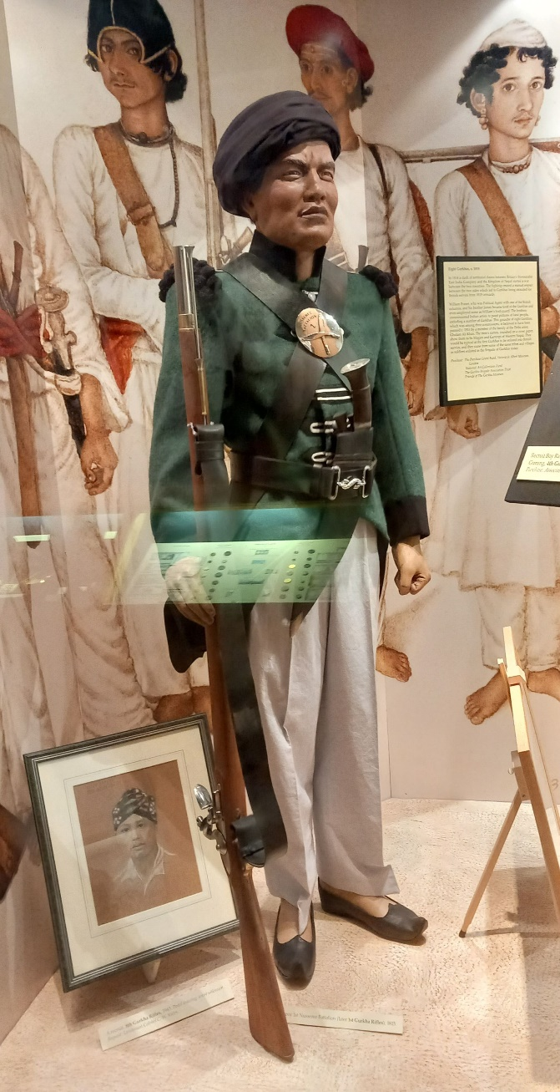 | 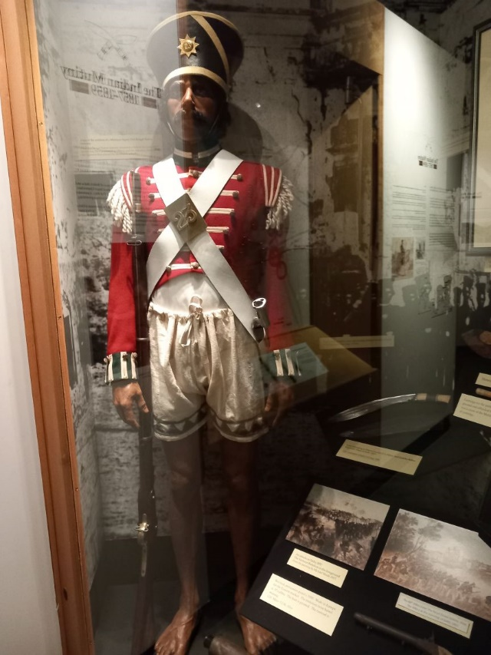  The uniform of a sepoy who mutinied against the British in 1857. I found that I had considerable respect for these many thousands of men who rose against the greatest Empire in the world without their trousers.  No wonder the Gurkas (1816) prevailed. We issued them trousers.

Wiki covers the Anglo-Nepalese War of 1814-16 https://en.wikipedia.org/wiki/Anglo-Nepalese_War . These campaigns were long and arduous. Ochterlony was the key figure in recruiting Gurkhas into the British Army. Recruited because of their expertise in mountain warfare, they served primarily on the North-west frontier but further afield in the 20th century. Gurkhas are recruited by the Armies of India and Pakistan but service in the British Army is seen as the ultimate prize. But nowadays Britain only takes about 250 recruits per year from, a filmclip explains, a pool of 18,000 who apply.

Summary
All the Museums were very well laid out and told their stories with carefully chosen exhibits, maps and models in well-lit cases. All a far cry from the piles of bits of metal in dusty cases that many of us remember from our childhoods and which nonetheless inspired us to learn more. Reflecting on these battles and campaigns across the Empire however one realised that most of the time most soldiers will have spent their time in barracks in some unhealthy part of the world,. Many will not have fired a shot in anger. Yet, and the Museums are not going to say otherwise, the Regiments made an effective transition from parade ground to battlefield. Maybe there could have been more on how units trained for the ultimate test over those decades and the developments in health and sanitation to keep the soldiers alive from disease.

Group Dinner
Eight of us gathered in the bar of the Winchester Royal prior to our Group Dinner at Brasserie Blanc a short distance away. One of the (reduced) chain of Raymond Blanc restaurants it was full yet the service and food were very good. Most unfortunately Bernard Hornung had to return home early and missed the meal. Although he had notified the restaurant they still produced the dishes he had ordered. We were pleased to assist in the disposal of his chocolate dessert!

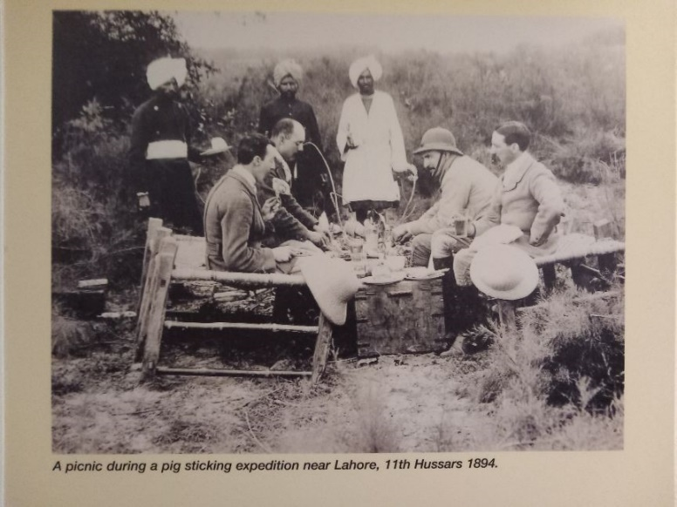  Changes in standards – outdoor catering 1894 and 1970’s. | 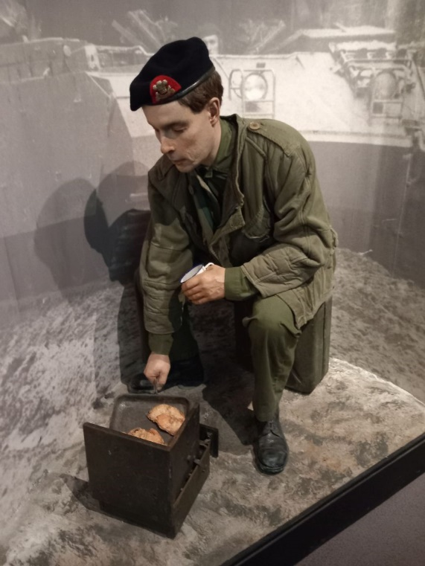

Andy Grainger

