Friday 6th May Wellington in London walk.
7.00am start
First stage of the journey was overground to Battersea Park station. This is to visit Battersea Park, where Wellington fought a duel in 1829. The station is a Victorian gem, seemingly untouched by modifications since its construction for the London, Brighton and South Coast Railway in 1865.

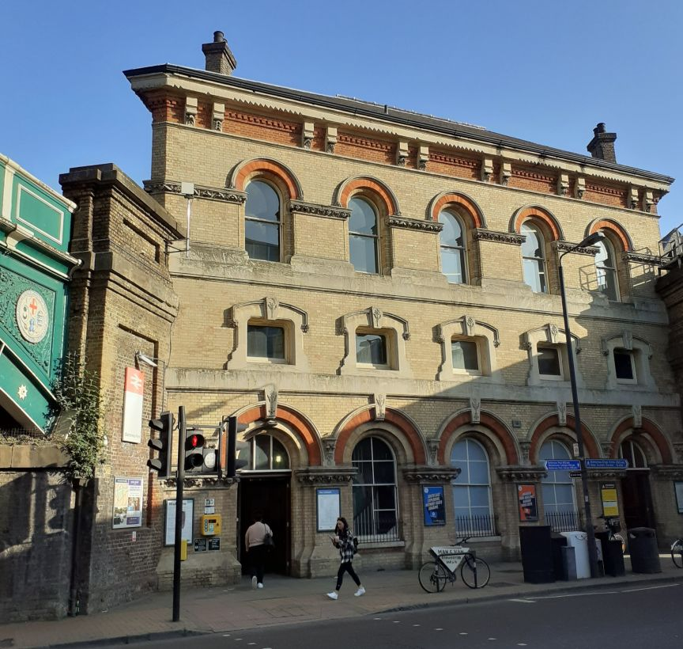
Battersea Park Railway Station 1865

In the Park, 15 of us meet at the Pear Tree café. The café opens at 8 and serves very nice bacon rolls. Andrew D says a few words about the Duel. This followed the passage of the Catholic Relief Bill – Catholic Emancipation. A staunch Protestant, the Earl of Winchilsea made some intemperate remarks to the Duke following statements that the Act would introduce Popery into every department of State. He declined to apologise for the more personal remarks, hence the duel at 6am on the then Battersea Fields near the river. The proceedings were attended by farce in that Wellington’s second, Sir Henry Hardinge, only had one hand and so was unable to load his Principal’s pistols whilst the Earl’s was so terrified he could not do so for his. Both sets (I believe that duellists always had a pair in case of misfires) were therefore loaded by the Doctor. Wellington fired but missed, whether by accident or design is not known whereupon the Earl fired in the air.

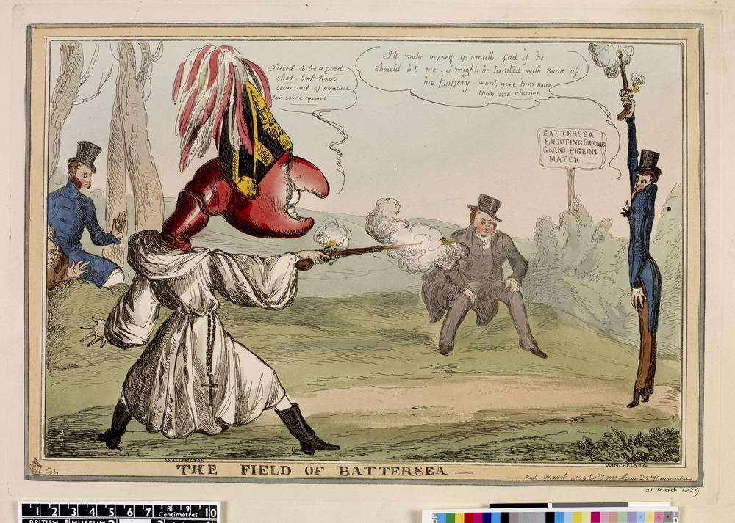

Wellington then rode to his desk at No.10 and made a report to the King later in the day. The Earl wrote a letter of apology. Will Fletcher added some background information on Hardinge.
Then a 137 bus to Wellington Arch at Hyde Park Corner, the only vehicular transport we took all day.

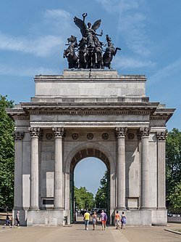
Wellington Arch
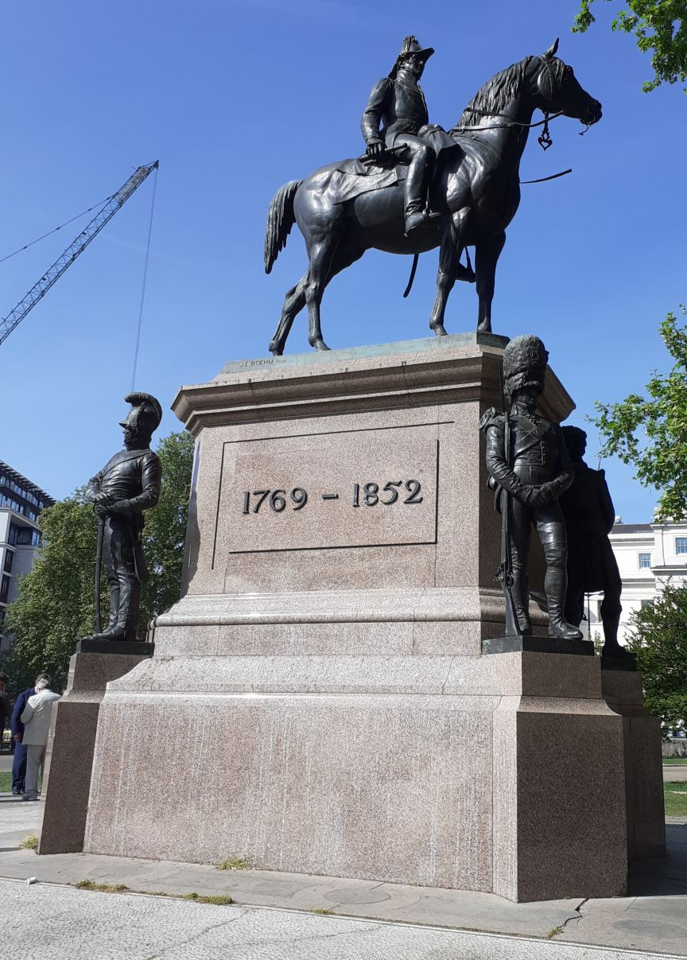
Wellington Statue

The Wellington Arch and Wellington Statue (which once sat on top of the Arch to the consternation both of its architect and critics) form part of a clutch of monuments at Hyde Park Corner. https://en.wikipedia.org/wiki/Wellington_Arch . The Wellington Arch (also known as Constitution Arch) and Marble Arch had both been designed as parts of a grand entrance plan for Buckingham Palace. They were to be complemented by a space commemorating the heroes of the Great War with France and the deeds of the House of Hannover…. ie Prinny.

Bernard H. explained Wellington’s relationships with his string of female confidantes, friends and mistresses - so the next stop is off Piccadilly in Shepherds Market at 5 Hertford Street. Now a private club, the building was apparently a purpose designed brothel. Nearby in Carrington Street, Harriette Wilson was born who, with her three sisters, became courtesans. In effect they were relatively poor women who tried to land themselves wealthy protectors or, preferably, a husband. To provide for her old age, Harriette wrote her memoirs - with which her publisher famously tried to blackmail Wellington. The Duke’s response has gone down to posterity https://en.wikipedia.org/wiki/Harriette_Wilson .

The Market retained its reputation for many decades, given the large number of Gentlemen’s Clubs in the area as well as the presence of many soldiers.

Then to where Angela Burdett Coutts, confidante of the Duke, lived, opposite Green Park tube.
We then strolled down Piccadilly to Prunier’s, now a purveyor of oysters and caviar but then the site of Wellington’s bootmaker George Hoby.. Bernard explained how officers in Wellington’s day had to buy their own uniforms. Hawkes, the Duke’s tailor was at the other end of Piccadilly at No.17 (later number No.14) Piccadilly.

Next stop is St James’s Square. We were met by Maj Gen Evelyn Webb-Carter. He led us into the East India Club, which, in 1815 was the building at which Prinny was attending a party when the doors were flung open and news of the victory at Waterloo was brought by one of Wellington’s few unwounded ADCs, Lt Percy. Along with Wellington’s Dispatch he also threw two captured French eagles at Prinny’s feet. The event was re-enacted in 2015 with Princess Anne as the Royal and the ADC arriving in a post-chaise. The replica eagles and flags are hanging beside the bar. The Maj Gen had kindly arranged for us to be served a lime and soda which was very welcome.

The Eagles and Flags

The Club is very opulent inside, big Georgian windows letting lots of light into the high ceilinged rooms. It was only founded in 1849 and the East India Co was disestablished ten years later. It since merged with the Public Schools Club.

Then along King Street where we stand with our backs to Christie’s at No.8. Opposite is Almacks House which stands on the site of Almacks, blitzed and demolished in 1941 whereas Christie’s was ‘just’ burnt out. Per the contemporary illustration Almacks was a barrack like building that was home to a very prestigious dancing club presided over by a committee of formidable women https://en.wikipedia.org/wiki/Almack%27s . Famously, in 1814, the Duke was refused admission on the grounds either that he was wearing trousers rather than knee breeches or that he was late. Several orchestras playing for Scottish dancing, the quadrille and even the waltz.

Next a short walk across Pall Mall to Waterloo Place where the Major General talked about the Athenaeum and the Duke of York whose memorial is on a column – to distance him from his creditors - at the top of the steps. Saw also a fairly new statue to Sir Keith Park and then a little monument to the dog of the German ambassador who died in office in 1936. At the time the German embassy was next to the Athenaeum and for reasons of protocol a fairly serious funeral had to be held. Thus we saw a photograph of pallbearers drawn from the Grenadier Guards carrying a coffin draped in an enormous swastika flag. Ironically the ambassador was not a supporter of the Nazi Government; he was replaced by Ribbentrop.

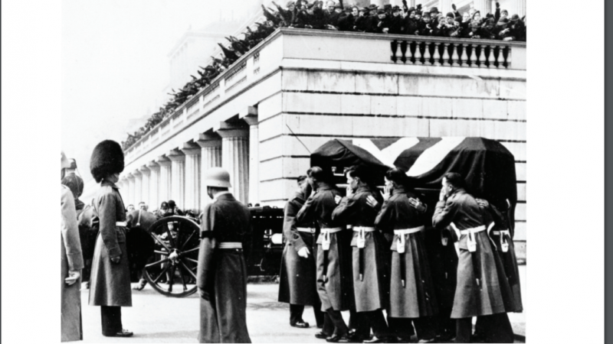
Funeral for the German Ambassador in 1936

Our next stop was another Holy of Holies, the office of the General Officer Commanding (GOC) London District which overlooks Horse Guards Parade - where the stands were being set up for the Trooping of the Colour. Evelyn was GOC for four years and the desk is that which the Duke used in this room. He explained how they found a coloured lithograph of the Duke interviewing the widow of a former officer and how they refurbished the room to match it. Typical Georgian, very pale green and white, big windows, high ceiling so lots of light. Bernard opened a bottle of Old Nosey Pear Liqueur from the farm where Spencer’s HQ (1st Division) was located so that we could toast the Duke.

Perhaps fittingly the desk is not some grand bespoke design from someone like Chippendale but appears to be of a standard model from the Sheraton catalogue. It is oval with four kneeholes and one can imagine in other rooms four clerks hunched over similar pieces of furniture. Evelyn explained that for a tall man like him it is really quite uncomfortable.

Wellington’s Desk

Downstairs we looked at the small Household Cavalry Museum which is very good and incorporates views into the stables where the men and horses prepare for guard mounting outside. There is even a section on the Cato Street Conspiracy in which two of the participants had been former soldiers of the Regiment.

The next stop was a well-deserved lunch at the Wellington pub at the far end of the Strand. It was a sunny day and the pavements outside the cafés and pubs were packed. We were lucky and get a table outside. Lunch was a pint of Nicholson’s and a beef brisket sandwich.

The Duke was a founding trustee of Kings College London and ensured it got the necessary land and Royal clearance. It was originally a sort of sixth form college for Theology students, favouring Protestants against UCL which favoured Dissenters. We were met by Andrew Lambert whose new book on Julian Corbett and naval strategy was published recently. Some of us remembered his barnstorming talk at Cambridge a few years ago on the subject of the War of 1812. The theme of this was a) that the Americans achieved none of their war aims and b) that the current generation of US historians do not understand that Britain was not really interested in them as we were busy dealing with Napoleon. Eventually, in the manner of someone swatting an annoying fly on a drowsy afternoon we burnt down Washington to make them go away. It is true that Pakenham screwed up appallingly badly at New Orleans – he was Wellington’s brother-in-law and had done well in the Peninsular. I think there is a quote by Wellington along the lines of ‘Oh God, they haven’t given an Army to Ned have they’. New Orleans turned out to be irrelevant as it was fought two or three weeks after the peace treaty had been signed.

The final stop was the Crypt at St Paul’s. Until recently the Crypt was Invitation Only; but now it has all been opened up and redesigned as an exhibition space with information panels, café and shop etc. We explored a rash of Napoleonic era monuments in the South Transept – Isaac Brock, our original commander in Canada in 1812 and killed early on. Given his limited resources he worked hard to get the key Indian chief Tecumseh onside and made a formal alliance with him. Unfortunately Tecumseh was killed some months after Brock and the London Govt did not follow through on the treaties. If they had it would have been a step change in our relationships with the native Americans. There is John Jones, the engineer of the Lines and Sir John Moore. There are many more. In the Crypt we have the tombs to Nelson and Wellington plus the two Trafalgar captains from Mars and Bellerophon. There are also plaques to all the WW2 Field Marshals and the colours of the Queen’s Regt and the Royal Fusiliers.

https://www.gardenvisit.com/book/london_and_its_environs_1927/25_st_pauls_cathedral/the_crypt_of_st_pauls_cathedral

This is where the tour ended and we gathered to thank Bernard. The day certainly went very well and we were blessed by the weather.

Bernard thanked General Christopher Ghika, for his kind permission to enter the Major General’s Office and Major-General Sir Evelyn Webb-Carter, for hosting us at The East India Club, and for adding so much colour, as he expertly joined up the dots from The East India Club to Horse Guards; also to Alison Davies, PA to the Maj Gen and Capt Jamie Roy, ADC to the Maj Gen.
Thanks also to Alex Bray the Secretary of the East India Club; to Alice Pearson, Director of The Household Cavalry Museum; to Professor Andrew Lambert for kindly receiving us at King’s College; Millie Walker and all her staff at St Paul’s Cathedral.
It was a very long day in which we apparently walked over 13 kms and visited two or three places into which the general public are not admitted. Well done Maj Bernard Hornung, Irish Guards.

Report prepared by Andrew Grainger

